H.T No
Regulations:
A20

Sreenidhi Institute of Science and Technology
(An Autonomous Institution)
Code No: 8B103 Date: 04-Feb-2025 (FN)

B.Tech I-Year I- Semester External Examination, Jan/Feb-2025 (Supplementary)
ENGINEERING MECHANICS (ME)

Time: 3 Hours Max.Marks:70

Note: a) No additional answer sheets will be provided.
b) All sub-parts of a question must be answered at one place only, otherwise it will not be valued.
c) Missing data can be assumed suitably.
Bloom's Cognitive Levels of Learning (BCLL)

Remember | L1 | Apply | L3 | Evaluate | L5
Understand | L2 | Analyze | L4 | Create | L6

Part - A Max.Marks:20

Answer all QUESTIONS.

 |  | BCLL | CO(s) | Marks
1 | List types of force systems. | L1 | CO1 | [2M]
2 | Define Truss and list its applications. | L1 | CO2 | [2M]
3 | Explain the terms angle of repose and cone of friction. | L2 | CO3 | [2M]
4 | Explain parallel axis theorem for transferring moment of inertia on to another parallel axis. | L2 | CO4 | [2M]
5 | List out the types of rigid body motions. | L1 | CO5 | [2M]
6 | Write a short note on coefficient of restitution. | L1 | CO6 | [2M]
7 | State and explain parallelogram law. | L1 | CO1 | [2M]
8 | Determine the centroid of a rectangle by integration method. | L1 | CO4 | [2M]
9 | Write the work-energy equation for translation and explain the terms. | L1 | CO6 | [2M]
10 | State and explain principle of virtual work. | L2 | CO3 | [2M]

Part – B Max.Marks:50
ANSWER ANY FIVE QUESTIONS. EACH QUESTION CARRIES 10 MARKS.

 |  |  | BCLL | CO(s) | Marks
11. |  | Two spheres A and B of weight 1000 N and 750 N respectively are kept as shown in the Fig. Determine the reactions at the contact points 1, 2, 3 and 4. Radius of A = 400 mm and Radius of B = 300 mm.  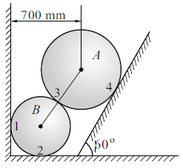 | L5 | CO1 | [10M]
12. |  | For the truss loaded as shown in Fig. Determine the support reactions and the forces in members AE, BC and EC.  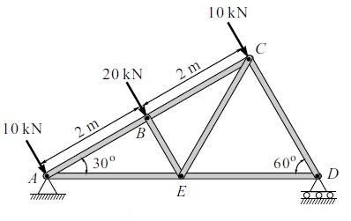 | L3 | CO2 | [10M]
13. |  | Two blocks W1 and W2 which are connected by a horizontal bar AB are supported on rough planes as shown in Fig. The coefficient of friction for the block A = 0.4. The angle of friction for the block B is 20⁰. Determine the smallest weight W1 of the block A for which the equilibrium can exist,  if W2 = 2250 N.  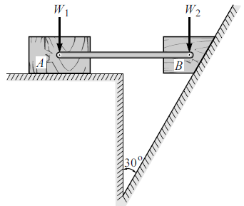 | L5 | CO3 | [10M]
14. |  | Calculate the moment of inertia of the planearea shown in Fig.about the centroidal x-axisand centroidal y-axis.  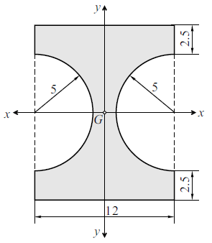 | L3 | CO4 | [10M]
15. | a) | A fly wheel starting from rest and accelerating uniformly performs 25 revolutions in 5 seconds. Determine its angular acceleration and its angular velocity after 10 seconds. | L5 | CO5 | [5M]
 | b) | A motorist is travelling at 90 kmph, when he observes a traffic light 250 m ahead of him turns red. The traffic light is timed to stay red for 12 sec. If the motorist wishes to pass the light without stopping, just as it turns  green. Determine (i)the required uniform deceleration of the motor and  (ii) the speed of the motor as it passes the traffic light. | L5 | CO5 | [5M]
16. |  | Two smooth spheres 1 and 2 having a mass of 2 kg and 4 kg, respectively collide with initial velocities, as shown in Fig. If the coefficient of restitution for the spheres is e = 0.8, determine the velocities of each sphere after collision.  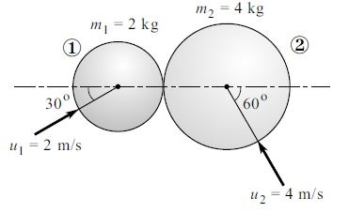 | L5 | CO6 | [10M]
17. |  | Compute the centroid of the following shaded plane area shown in Fig. [All dimensions are in mm]  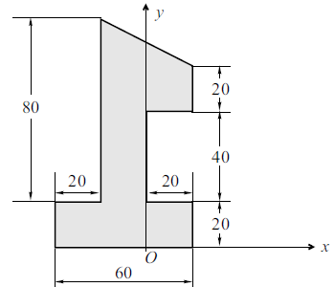 | L3 | CO1 | [10M]
18. |  | A mass of 20 kg is projected up an inclined of 26⁰with velocity of 4 m/s, as shown in fig. If µ = 0.2, (i) Determine maximum distance that the package will move along the plane and (ii) What will be the velocity of the package when it comes back to initial position ? | L5 | CO6 | [10M]
-- 00 -- 00 –

